MILL STRAND INTEGRATED PRIMARY SCHOOL & NURSERY UNIT

Promoting Excellence, Celebrating Difference

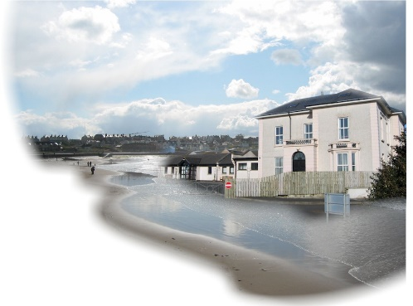

School Closures 2020/21

We await further Executive/Department of Education directives regarding starting dates and arrangements for various year-groups, including any phased or staggered return. Details will be communicated once confirmed.

*Please note that these holidays and school closure could be subject to change due to the COVID-19 Pandemic.

PARENTS/PUPILS

Following the Summer Holidays, school will re-open for pupils on Monday 24th August 2020.

Halloween Break 26th October 2020 – 30th October 2020 inclusive*

Christmas Holidays School closes 12 Noon Friday 18th December 2020
19th December 2020 – 4th January 2021 inclusive*

February Half-Term 15th February 2021 – 19th February 2021 inclusive*

St Patrick’s Day 17th March 2021

Easter Holidays 29th March 2021 – 9th April 2021 inclusive*

NW200 Closures 10th May 2021 – 14th May 2021 inclusive*

May Bank Holiday 31st May 2021

Summer Holidays School Closes 12 Noon Wednesday 30th June 2021

Please note that the above dates of closure also include Baker and School Development Days where staff are present, but pupils do not attend.

